Oscar Lopez
CS443
10/30/24
Assignment 2

- Write a select statement to list all the columns from the Offices table. 'Select *' is not allowed. Return the list in DESC Office order.

Syntax shown below and in photo:

SELECT office, city, region, mgr, target, sales
FROM offices
ORDER BY office DESC;

OUTPUT:
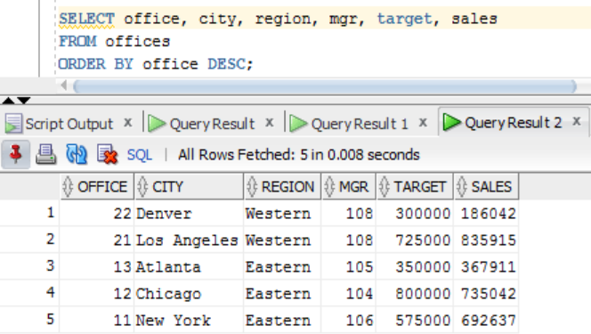
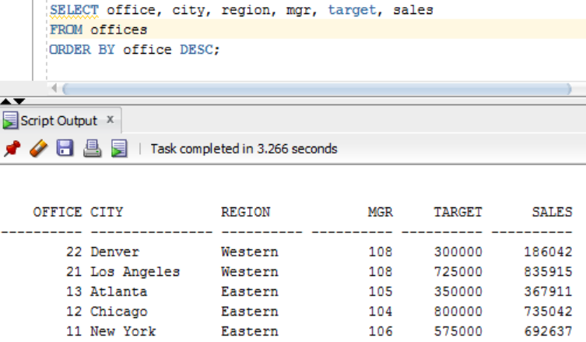
- List the product id, mfr id, Name (its description), and dollar value of quantity on hand (price * quantity) of the products that their dollar value is greater than 20000. Return the list in descending order by their dollar value.
Syntax shown below and in photo: (PRICE * QTY_ON_HAND) = Dollar value
SELECT MFR_ID, PRODUCT_ID, DESCRIPTION, (PRICE * QTY_ON_HAND) AS dollar_value
FROM PRODUCTS
WHERE (PRICE * QTY_ON_HAND) > 20000.00
ORDER BY dollar_value DESC;

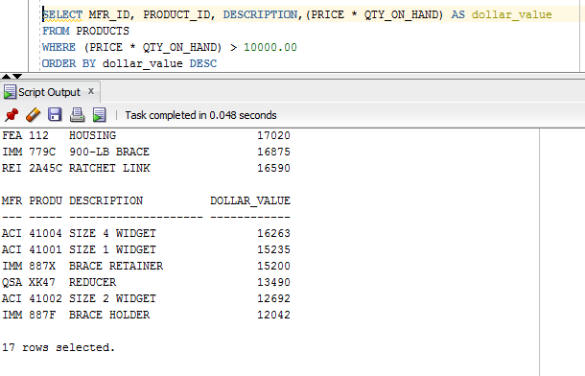

- List the Order Number, Order Date, Customer Number and Sales Rep Number for orders for part '779C' or '773C'. (Use a compound search condition - OR.)

Syntax shown below and in photo:

SELECT ORDER_NUM, ORDER_DATE, CUST, REP
FROM ORDERS
WHERE PRODUCT = ‘7796’ OR PRODUCT = ‘773C’;

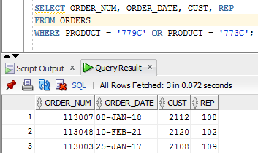
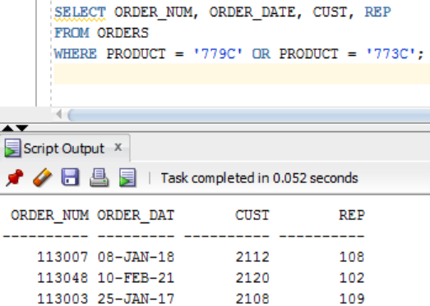
- List the Name and Age for all Sales Reps in the following offices: 11; 13. (Use the set membership test - IN.)

Syntax shown below and in photo:
SELECT name, age
FROM salesreps
WHERE rep_office IN (‘11’,’13’);
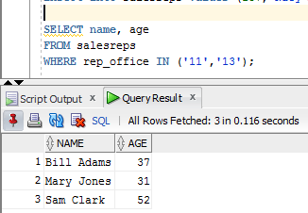
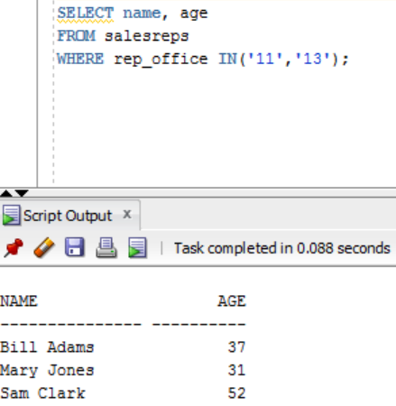
- List the names of all Sales Reps who have the letter 'a' (this is lower case a) as the second character of their name.

Syntax shown below and in photo:
SELECT name
FROM salesreps
WHERE name LIKE ‘_a%’;
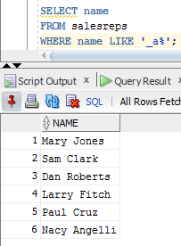
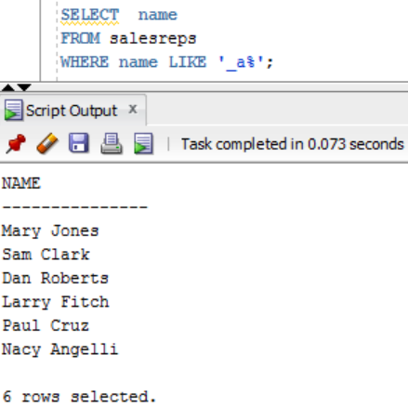

- Return the Sales Rep ID and Name of any Sales Rep not assigned to an office yet.

Syntax shown below and in photo:
SELECT empl_num, name
FROM salesreps
WHERE rep_office is NULL;
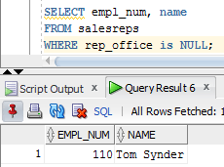
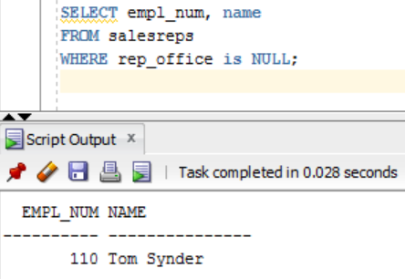
- Show all the sales rep names with last name “Smith” or “Jones”.

Syntax shown below and in photo:
SELECT name
FROM salesreps
WHERE name LIKE ‘%Smith’ OR name LIKE ‘%Jones’;

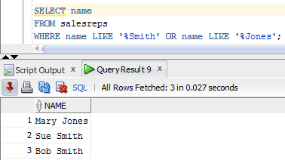
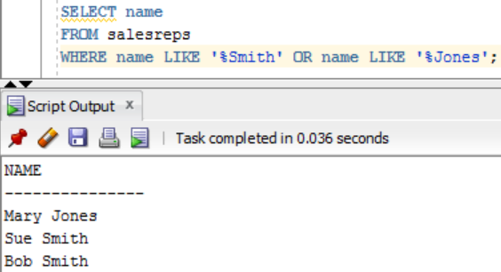
- List different titles in the sales reps table. Only list each title once and unknown titles should be ignored. Duplicate rows are not allowed.

Syntax shown below and in photo:
SELECT DISTINCT title
FROM salesreps
WHERE title IS NOT NULL;

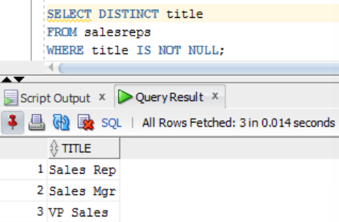
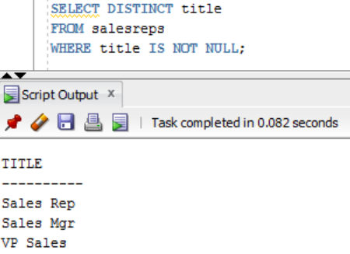

- List the description of the products which are more than 6 character and less than 10 character long. No duplicate row is allowed. You can use the build in function length() to do this. For example, length(name) return the number of characters for attribute called “name”.

Syntax shown below and in photo:
SELECT DISTINCT description
FROM products
WHERE length(description) > 6 AND length(description) < 10;

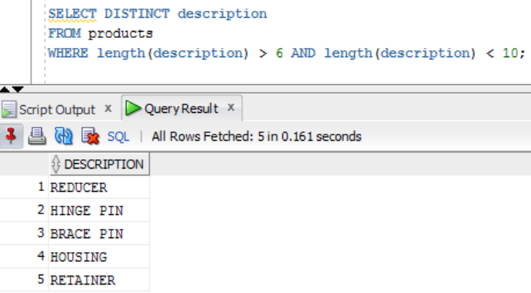
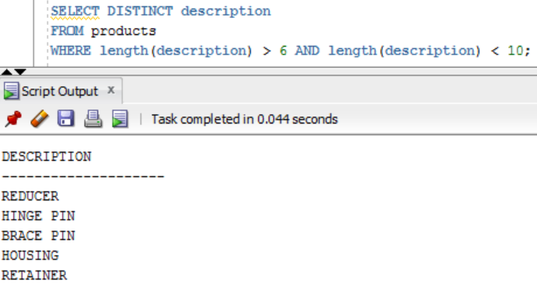

- For all order Amount less than $700, list the order num with the name of the rep who placed the order and the name of the customer who made the order and the name of the rep for that customer

Syntax shown below and in photo:

SELECT ORDER_NUM, s.name AS “REP_NAME”, company, cust.name AS “CUST_REP”
FROM ORDERS, salesreps s, customers, salesreps cust
WHERE rep = s.empl_num AND cust_num = cust AND cust_rep = cust.empl_num AND amount < 700.00;

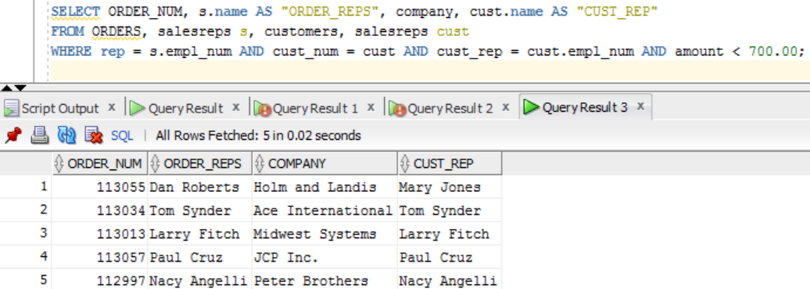
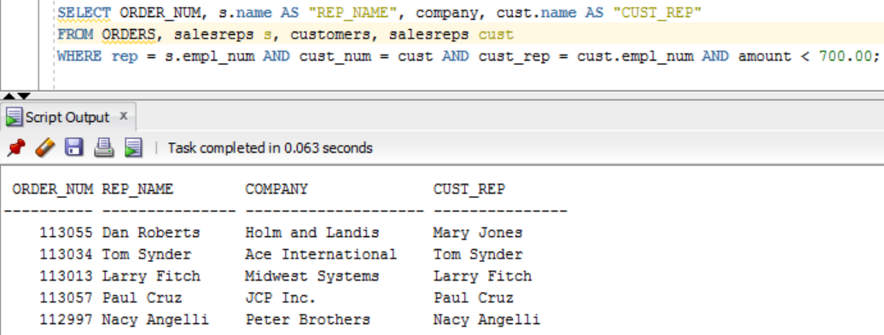

- List the Mfr Id, the Product Id, Company and PRICE of all products bought by customers where customer number is one of (2111,2112,2105,2119) and where the amount of the order < $10,000. Order the results by ascending Company. Duplicate row are not allowed.

Syntax shown below and in photo:

SELECT DISTINCT MFR_ID, PRODUCT_ID, COMPANY, PRICE
FROM PRODUCTS, customers, ORDERS
WHERE product = PRODUCT_ID AND mfr = MFR_ID AND cust = CUST_NUM AND CUST_NUM IN (2111,2112,2105,2119) AND amount < 10000.00
ORDER BY COMPANY ASC;

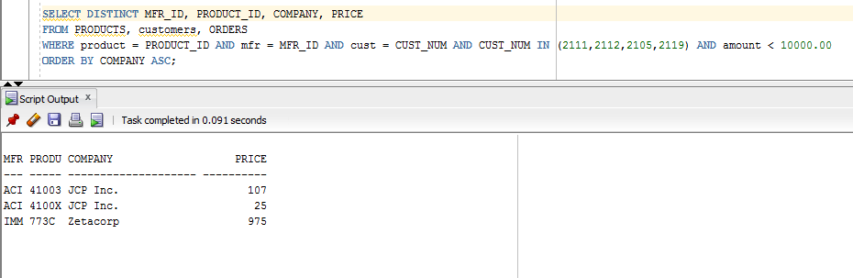

- List all orders number, the name of the rep who took the order , the city where the rep has his/her office. Print the employee whose office is in either Chicago or Denver;

Syntax shown below and in photo.

SELECT ORDER_NUM, salesreps.name, offices.city
FROM offices, salesreps, ORDERS
WHERE salesreps.empl_num = ORDERS.REP AND salesreps.rep_office = offices.office AND offices.city IN (‘Chicago’,’Denver’);

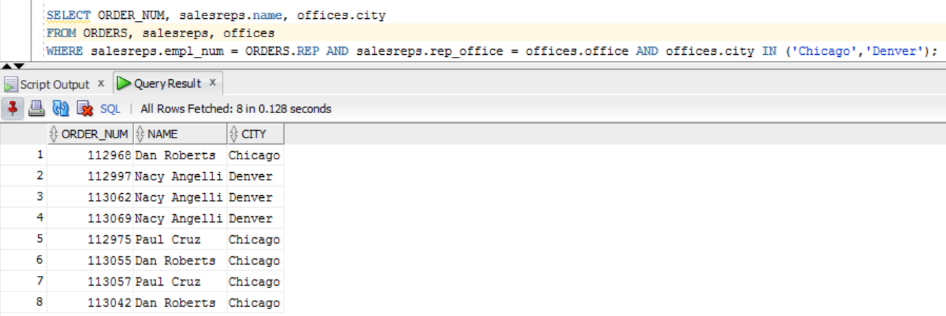
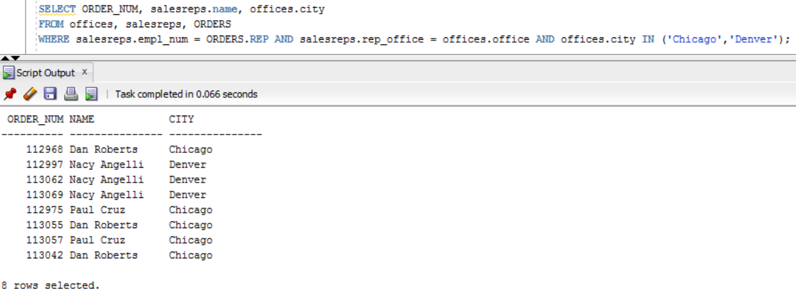

- List all customers (Customer number, Company, and Credit Limit) and orders (Order Number, Amount) where the Amount is within $10000 of the Credit Limit. Therefore:
- Credit_limit should be greater than zero and
- Amount should be greater than zero and
- Amount should be less than credit_limit and
- Credit_limit – Amount <=$10,000
Syntax shown below and in photo.
SELECT CUST_NUM, COMPANY, CREDIT_LIMIT, ORDER_NUM, AMOUNT
FROM customers, ORDERS
WHERE CREDIT_LIMIT > 0.00 AND AMOUNT > 0.00 AND AMOUNT < CREDIT_LIMIT AND (CREDIT_LIMIT - AMOUNT) < = 5000.00 AND CUST_NUM = CUST;
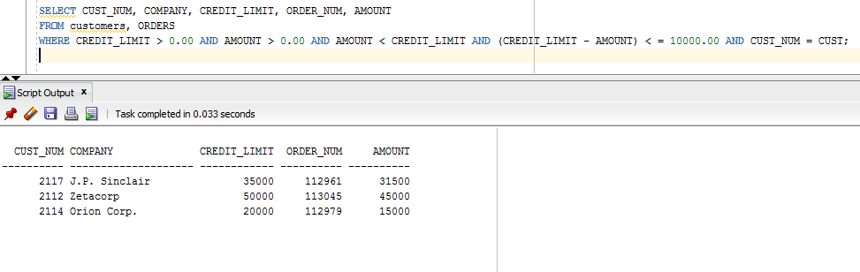
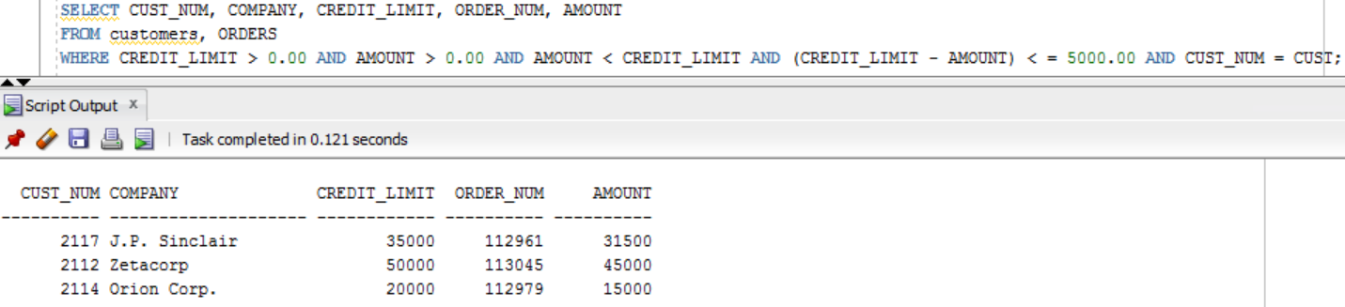
- List all salesreps names and their managers’ names where the salesrep is at least as old as the manager. Duplicate rows are not allowed.
Syntax shown below and in photo.
SELECT e.name AS “EMPL_NAME”, m.name AS “MANAG_NAME”
FROM salesreps e, salesreps m
WHERE m.empl_num = e.manager AND e.age >= m.age;

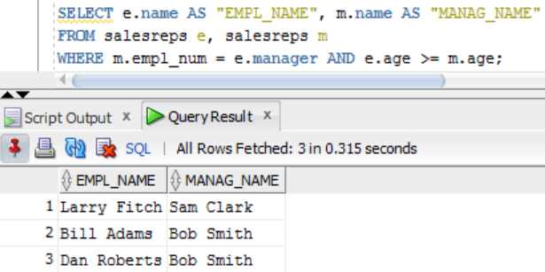
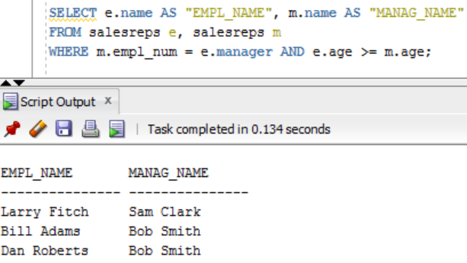

- List all salesreps (Name) and the City they work in where either the sales of the salesrep < Quota or the sales for the office is < Target.
Syntax shown below and in photo.
SELECT name, city
FROM salesreps, offices
WHERE salesreps.rep_office = offices.office AND (salesreps.sales < salesreps.quota OR offices.sales < offices.target);
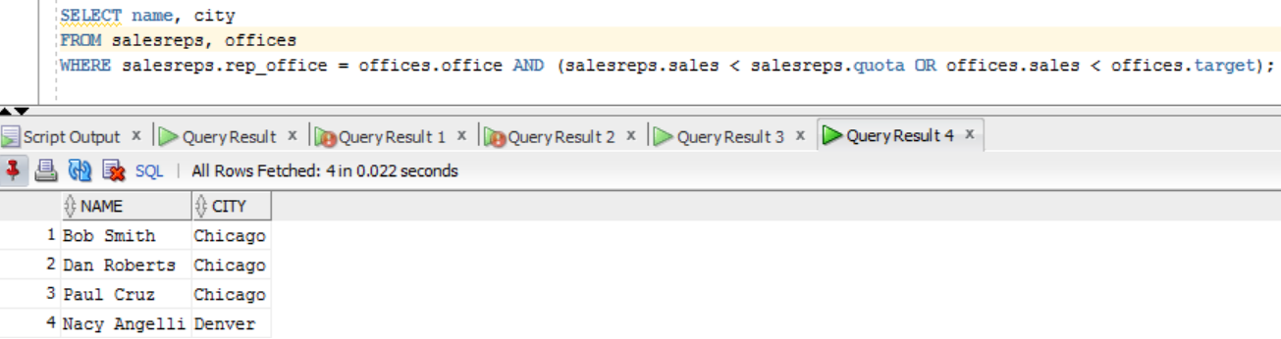
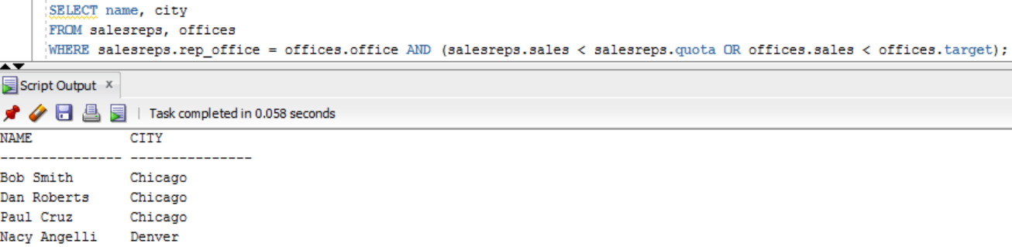
- List the name, id, and hire date of the salesreps where the following two conditions hold:
- The salesrep sales should be greater than the quota and
- The rep should be either “Sam Clark”, or “Mary Jones”

Syntax shown below and in photo.

SELECT empl_num, name, hire_date
FROM salesreps
WHERE (sales > quota) AND name LIKE ‘%Mary Jones’ OR name LIKE ‘%Sam Clark’;

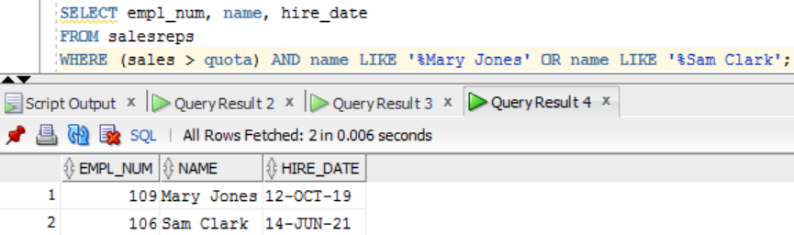
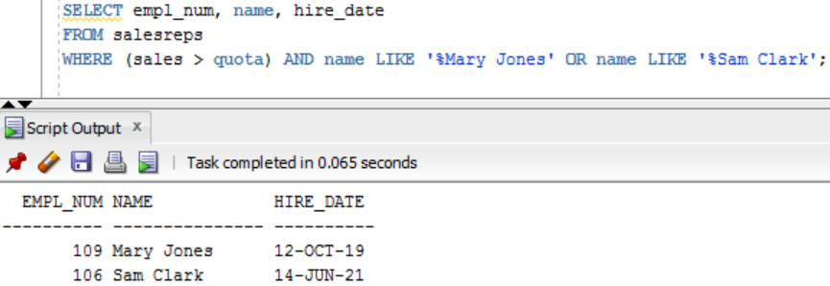
- List all orders (Order Number) over $7,000 showing the company placing the order, the Customer Rep assign to the company, the Office id and the city , and the rep who took the order where such that the Customer Rep’s is not the rep who took the order.

Syntax shown below and in photo.

SELECT order_num, company, c.name AS “CUSTOMER_REP”, office, city, r.name AS “REP_ORDER”
FROM orders, customers, salesreps c, offices, salesreps r
WHERE amount > 7000.00 AND c.empl_num = cust_rep AND c.rep_office = office AND cust = cust_num AND manager != rep;
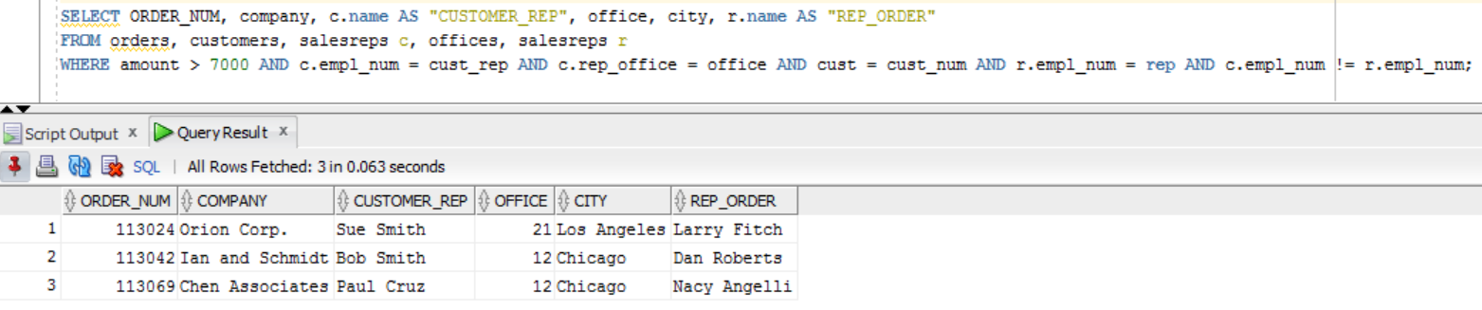
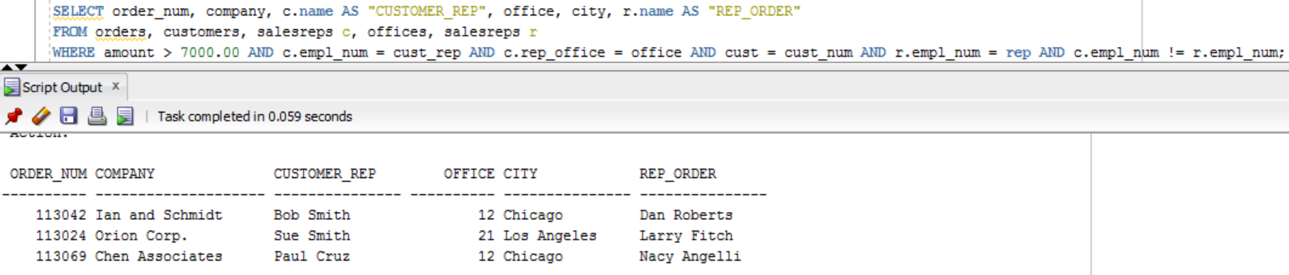
- List all customer reps (their name and their id) and their managers name in which the manager is based in New York. Use appropriate column header.
Syntax shown below and in photo.
SELECT DISTINCT employee.empl_num, employee.name AS “EMPLOYEE_NAME”, managerr.name AS “MANAGER_NAME”
FROM customers, offices, salesreps employee, salesreps managerr
WHERE employee.manager = managerr.empl_num AND managerr.empl_num = offices.mgr AND offices.city IN (‘New York’);
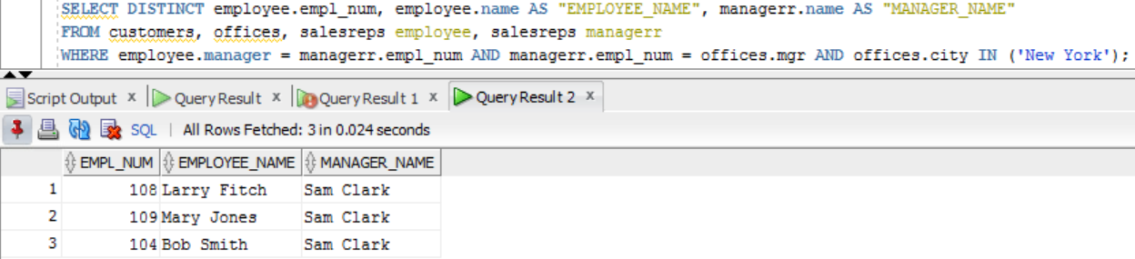
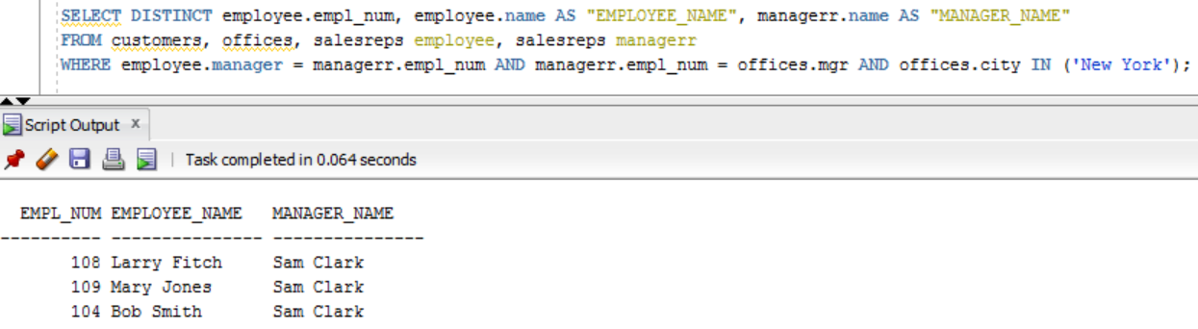
- List all products (ProductId, MFR_Id, and Description), customers (CustNum, Company) who have bought that product, and orders (Order Number, and Order Date) where the order < $700. Sort the rows by the OrderDate. Duplicate rows is not allowed.
Syntax shown below and in photo.
SELECT PRODUCT_ID, MFR_ID, DESCRIPTION, CUST_NUM, COMPANY, ORDER_NUM, ORDER_DATE
FROM PRODUCTS, customers, ORDERS
WHERE cust = CUST_NUM AND product = PRODUCT_ID AND mfr = MFR_ID AND amount < 700.00
ORDER BY ORDER_DATE;
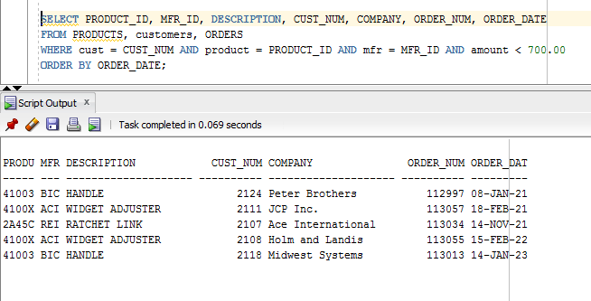

- List the name of the salesreps and the name of their managers only if the manager has taken care of some orders.

Syntax shown below and in photo.

SELECT DISTINCT employee.name AS “EMPLOYEE_NAME”, managerr.name AS “MANAGER_NAME”
FROM salesreps employee, salesreps managerr, orders
WHERE employee.manager = managerr.empl_num AND rep = managerr.empl_num;

